This is a brain dump of what I have learned over the past couple of years using my LoboCNC Router/Mill. It starts with the basics and rambles a bit, eventually getting around to specifics about how to actually make things. Norm Brewer

Contents

CAD/CAM Precautions 1

CAD/CAM Overview 2

2D, 2.5D and 3D CAD 2

The CAM program 3

The post-processor program 3

Back Plotter Program 4

Lobo Hardware 5

Lobo PSCNC Software 6

The Router 7

Materials 8

Three projects 9

Lobo_part1 – A simple 2.5D project 9

Drawing the 2D Part 9

Import DXF file into CamBam 10

Defining Machining Operations to make a 2.5D product 11

Coordinate Center 11

Adding Holding Tabs 12

Generating G-code and running the back-plotter 13

Running the Machine 14

Lobo_part2– V-Carved letters 16

Lobo_part3– 3D project 17

Tips 17

Hybrid techniques 18

# CAD/CAM Precautions

You may have experience with 3D printing or laser cutting, but CNC machining is different. The cutters you use to cut out your project can also damage the CNC machine, vices, and work holders. You can easily damage the machine, especially if you leave it unattended. Be careful to not to use high cut or plunge rates and watch the entire process being ready to abort at the first sign of trouble. Use back-plotters or simulation software to test your G-code before running.

# CAD/CAM Overview

The process of making something starts with an idea. From there you progress to a detailed design which you draw using a **computer aided design** **“CAD”** program. There are lots of CAD tools available such as SolidWorks, Sketch up, CorelDraw, AutoCAD, CAMBAM, and many others. They all have a fairly steep learning curve, so you just have to pick one and learn it. You should be able to use the same CAD program for CNC milling, 3D printing, and Laser Cutting/Engraving.

## 2D, 2.5D and 3D CAD

A 2D design is just a line drawing of a part showing the outline and internal details. The figure below shows a simple line drawing of a part we’ll see more of later on.

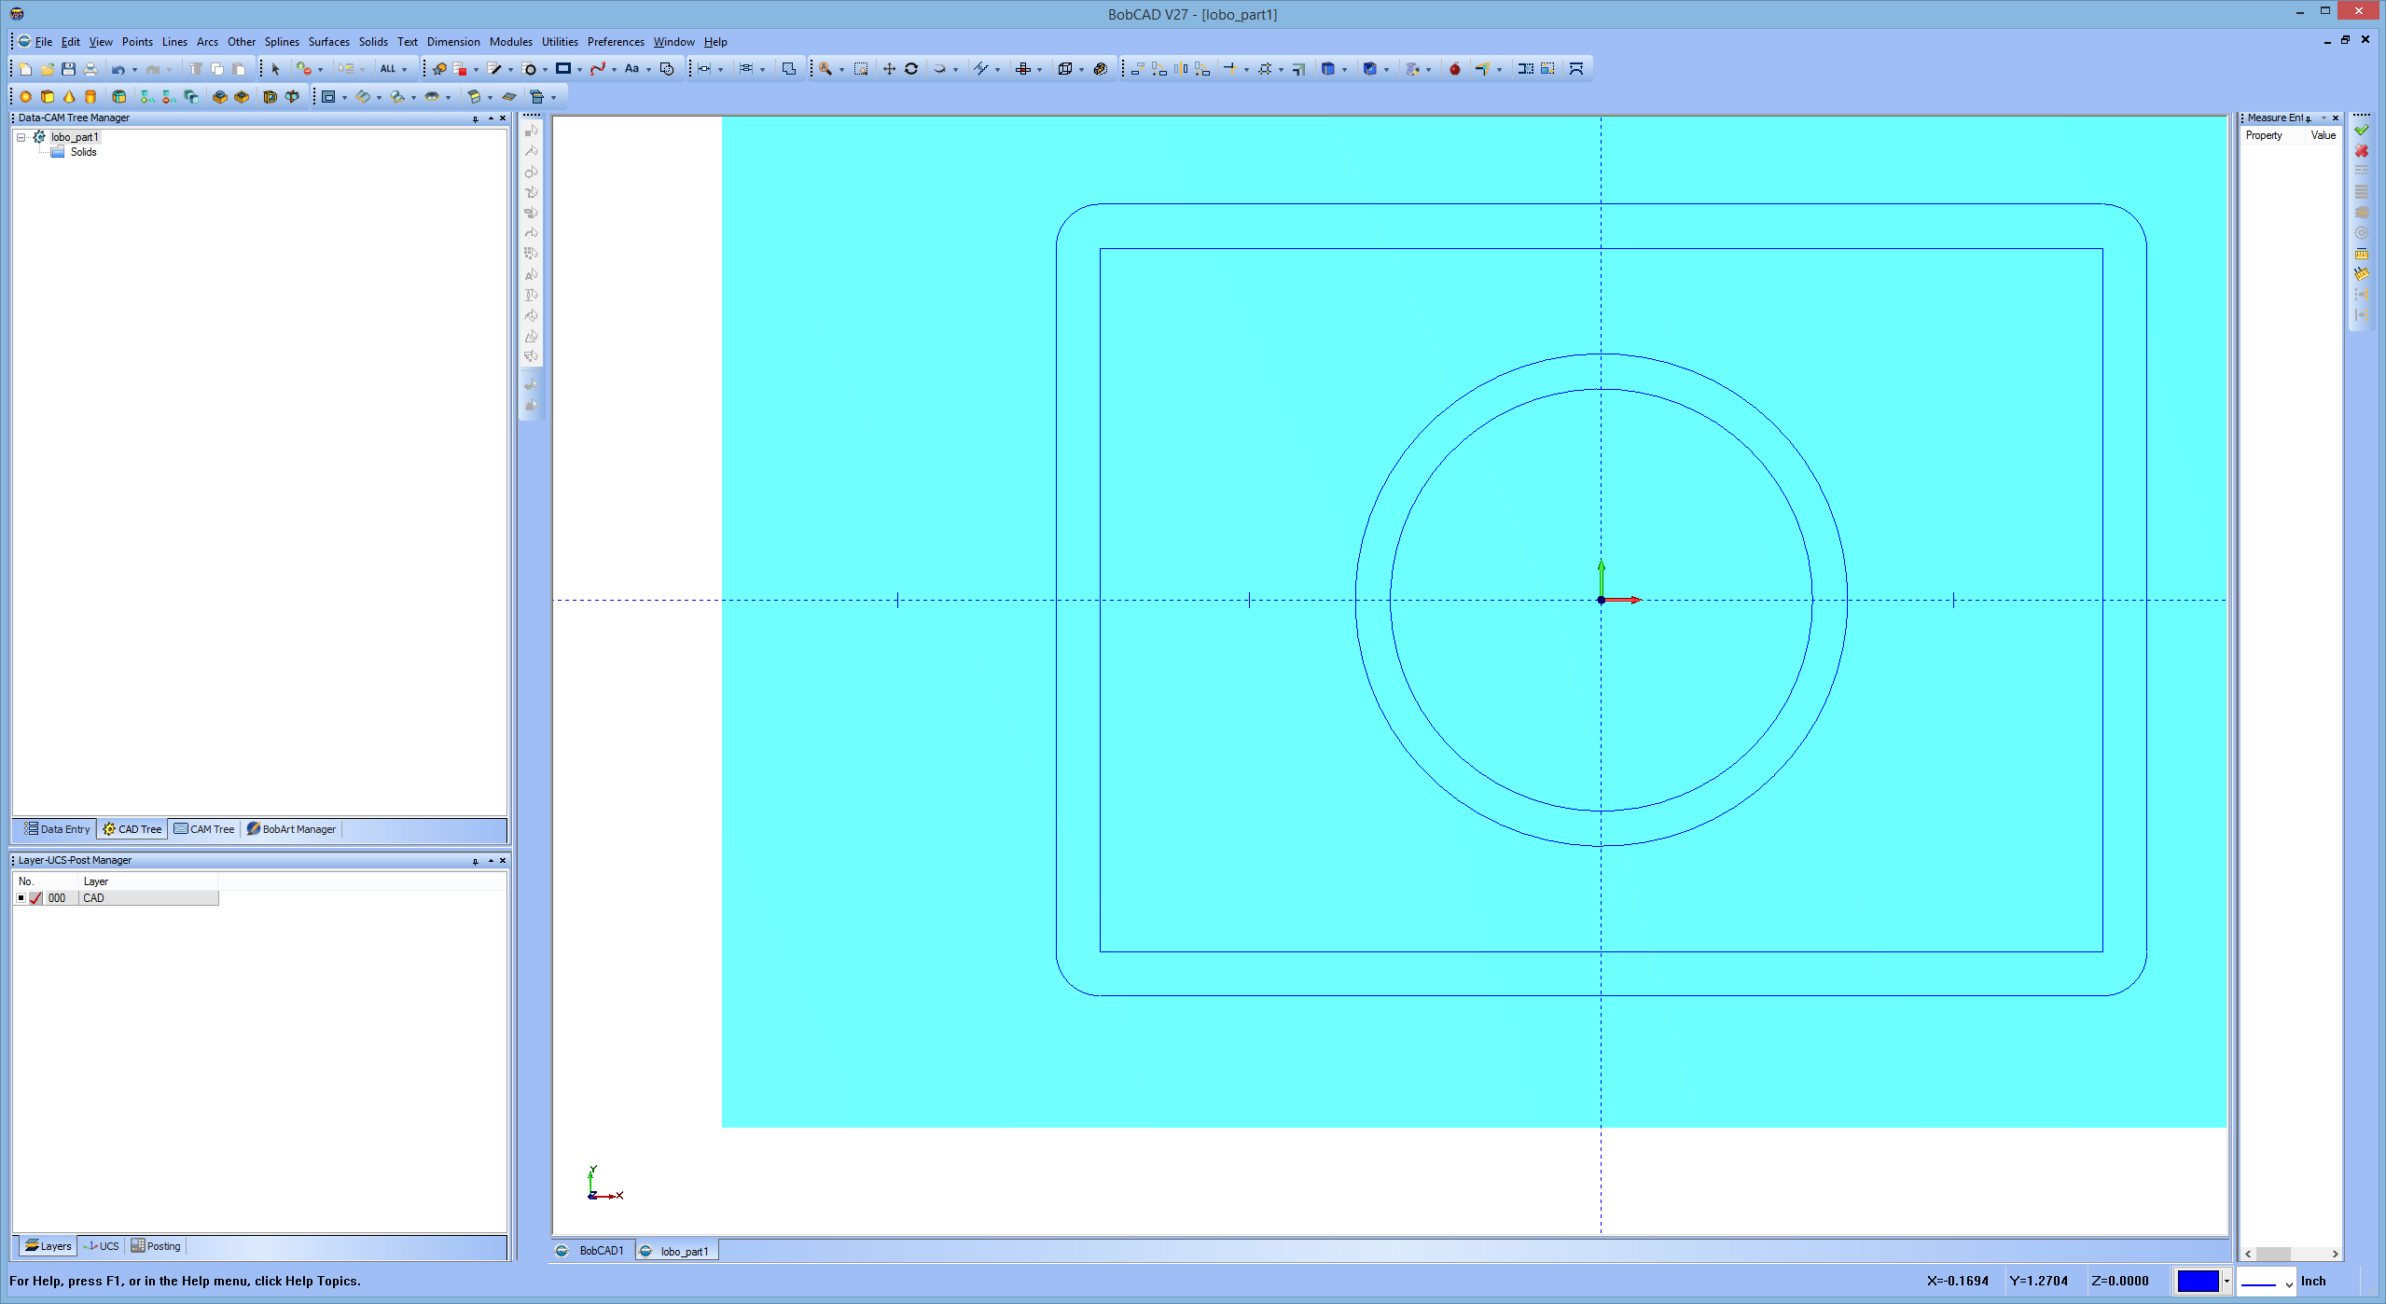

Figure - 2D model

CAM software can convert this to a 2.5D model where you specify how deep to cut each detail (the 0.5 part of 2.5D). The CAM program also generates instructions (G-code) to run the mill. [For more information about G-code see Wikipedia](https://en.wikipedia.org/wiki/G-code).

A 3D design is a complete solid model of the part you are trying to make and can also be converted to G-code. The photo below shows a 3D bow to be carved into a piece of wood. I purchased this model on the internet as an .STL file. You can build your own or use a scanner to make a 3D model.

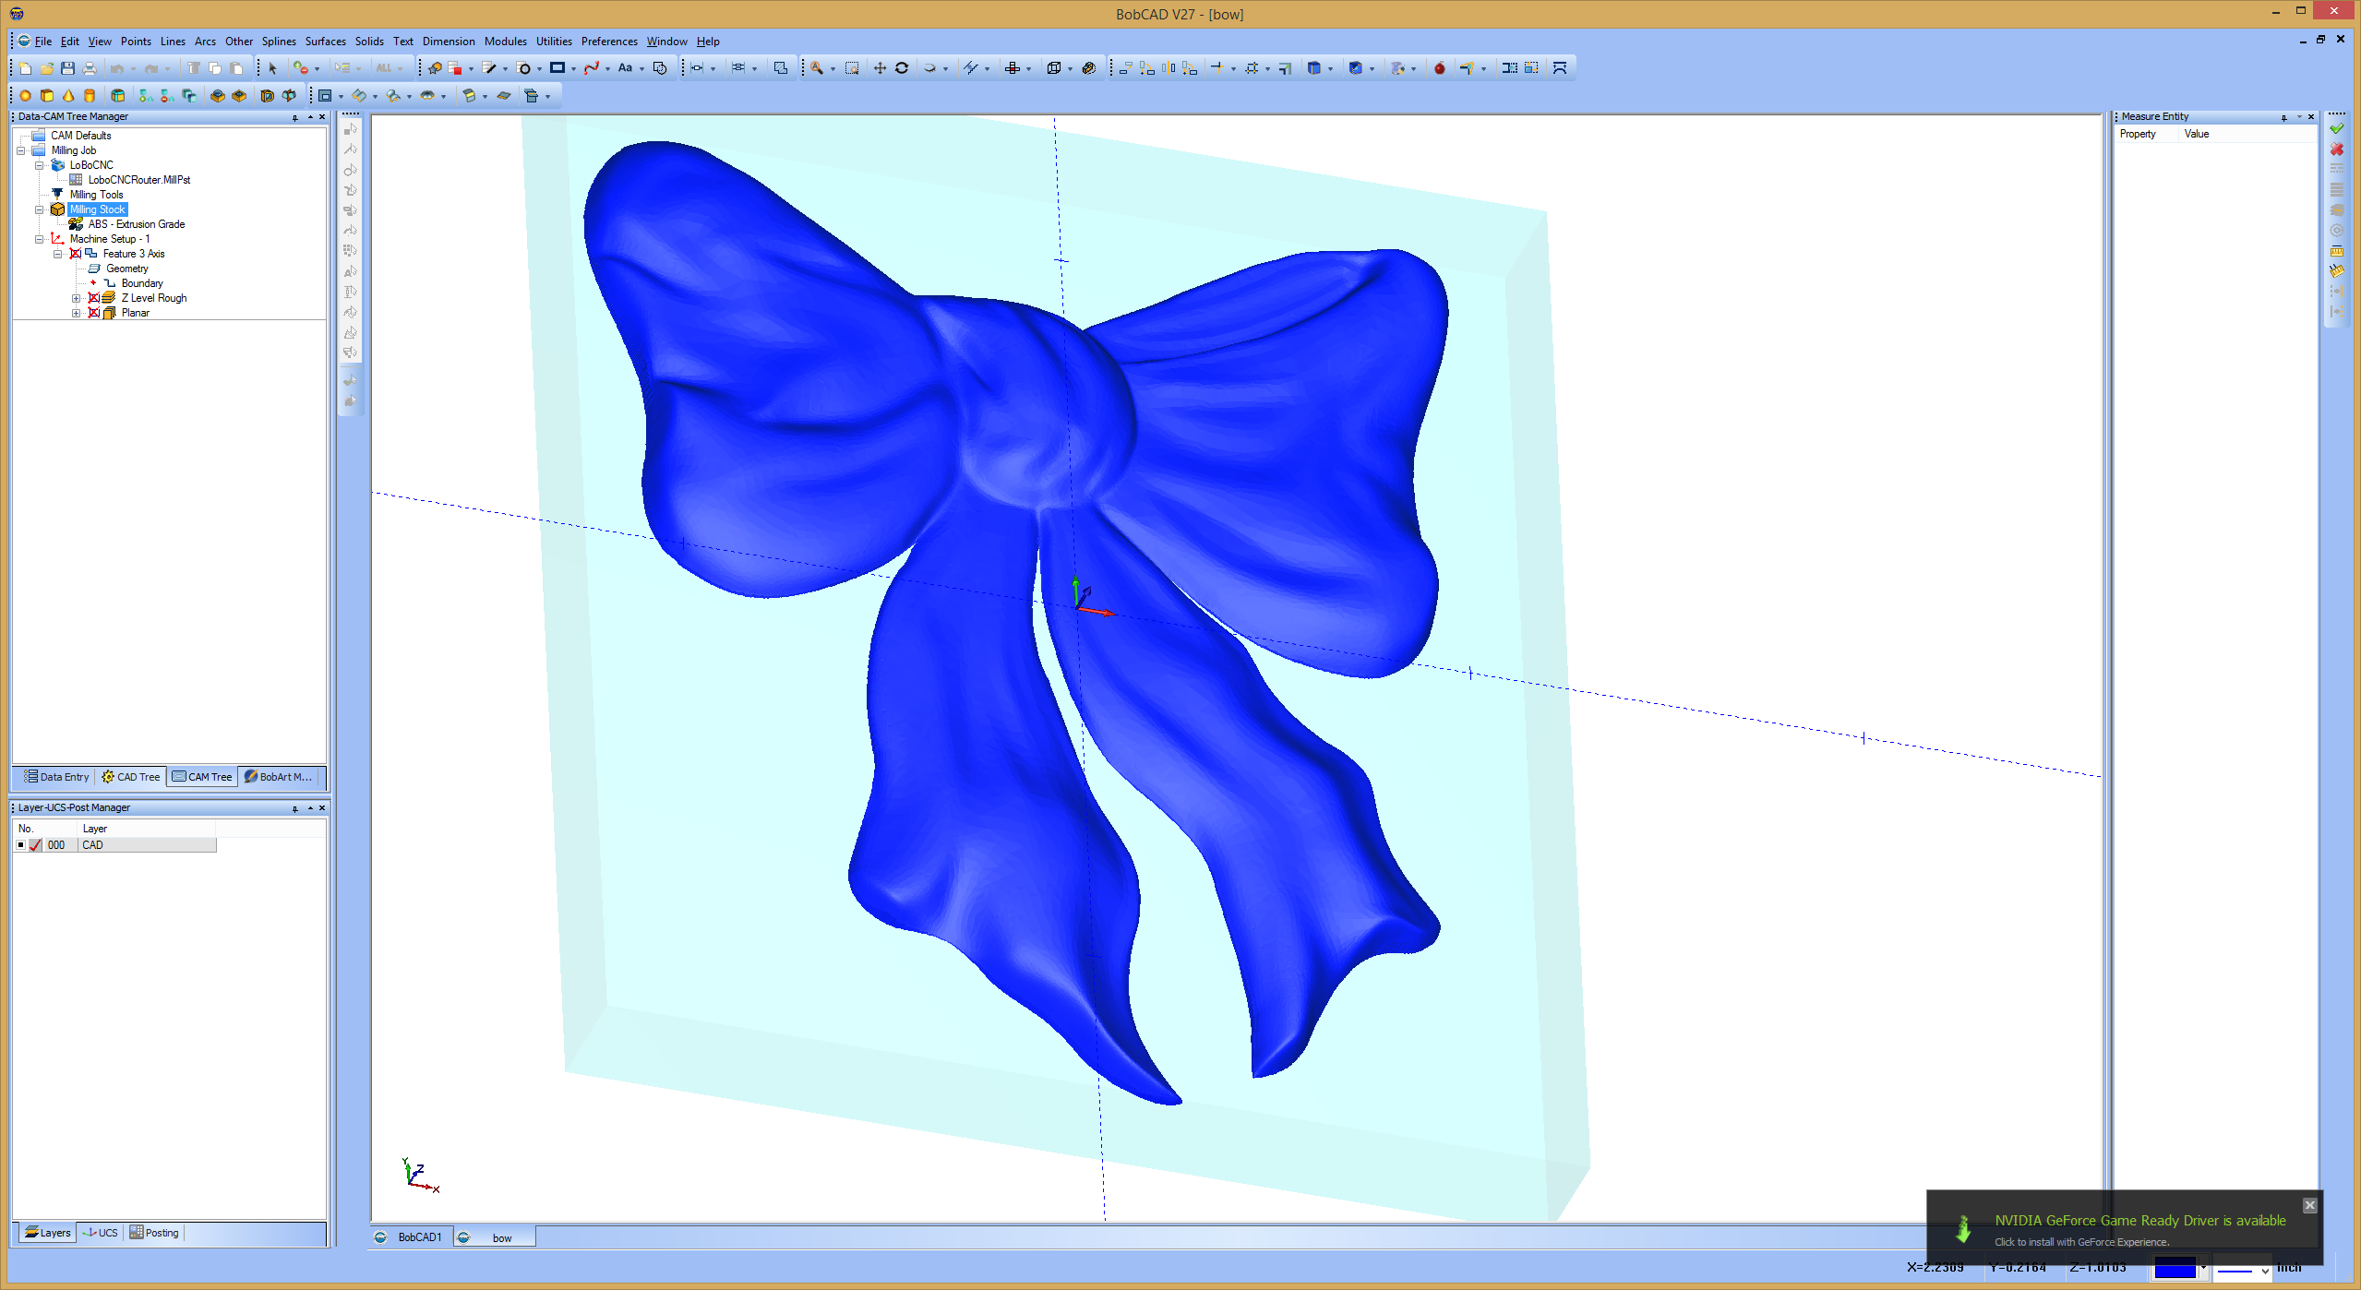

Figure - 3D model rendered in BobCad/Cam

## The CAM program

The **computer aided manufacturing (CAM)** program combines a drawing with manufacturing information you supply to produce the G-code needed to run the machine. The information you supply includes a description of the cutting tool geometry, travel speeds and depth of cut for 2D models. Sometimes the CAD and CAM components are combined into one program like CAMBAM.

The CAM program computes the toolpath needed to produce your item. The G-code is just a text file which contains the commands needed to produce your design. You can read it with notepad, but context sensitive G-code editors can help you decipher that it contains. Normally you don’t have to directly edit the G-code unless you have a special problem to deal with.

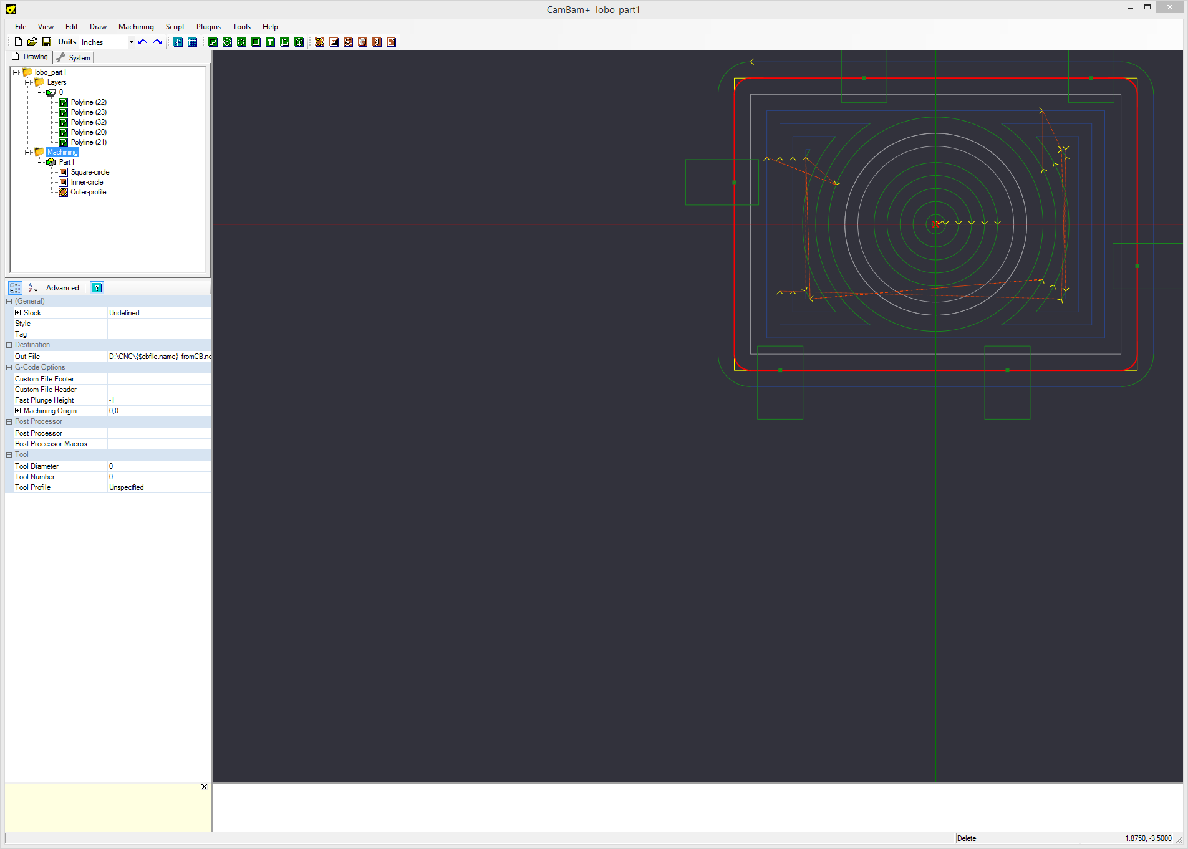

Figure - CAMBAM view of model

## The post-processor program

A CAM program needs to understand the exact dialect of G-code that your CNC machine uses. You provide these details by choosing or writing a **“post-processor”** program that produces the correct code. For example, a coordinated G-code move is: **g1 xnnnn ynnnn znnnn.** The post-processor can convert this to **G01 X0.nnnn Y0.nnnn Z0.nnnn** if your CNC machine’s G-code interpreter wants upper case only.

## Back Plotter Program

A **simulation or back-plotter program** can process the G-code file and show you what it would “hopefully” do on a real machine. This only works correctly if the back-plotter program has the same understanding of G-code as the actual CNC machine. These programs also tell you how long the G-code will take to run.

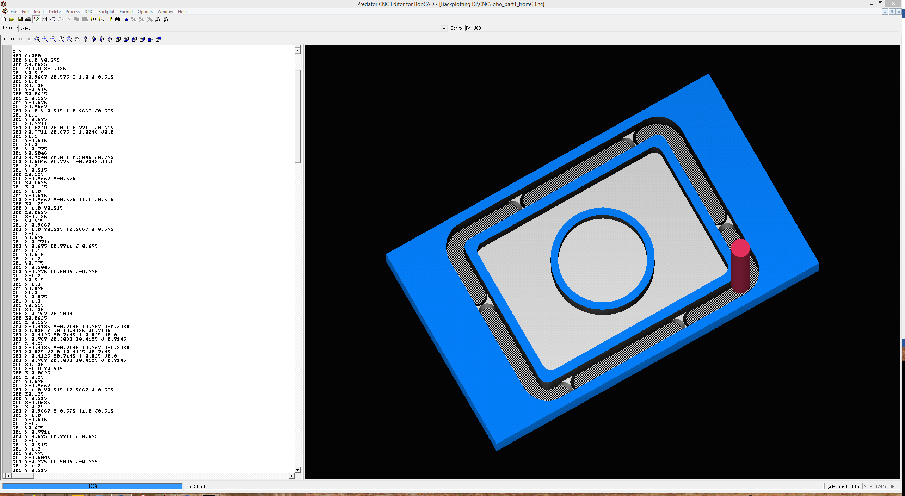

Figure - Back Plotter Rendering of G-code produced by CamBam G-code file

There is a back-plotter available for CamBam called CutViewer as an extra cost option.

# Lobo Hardware

Jeff Kerr designed the LoboCNC hardware and software. His web site <http://jrkerr.com/lobocnc/> provides a great deal of information about the mill, the software, and some sample projects he has done. It is a good place to start learning about CNC milling and **you should read it**! The web site also explains direction of travel and zero position.

LoboCNC is a 3-axis machine, with X travel of about 10”, Y travel about 6”, and Z movement of about 6”. LoboCNC takes a 2” diameter router and is the machine is stiff enough to machine plastic, wood, and soft metals like aluminum and brass. The LoboCNC mill has digital servo motors that consist of stepper motors combined with rotary encoders that provide angular position feedback. The LoboCNC S3x3 motor controller board runs the X, Y, and Z motors to achieve the desired motion.

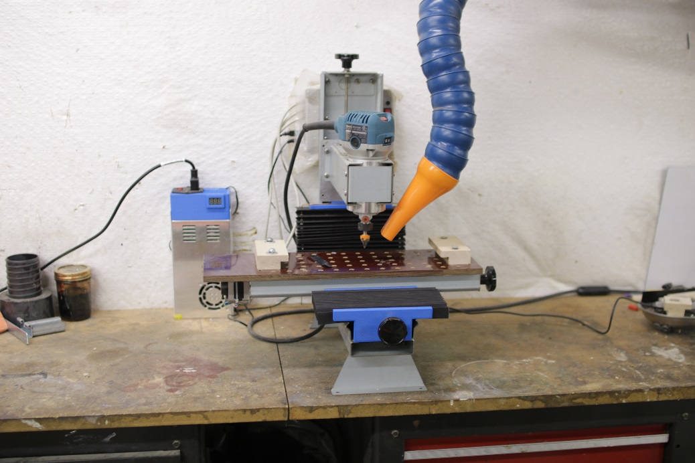

Figure – My LOBOCNC Mill/router

The S3x3 controller is in a box behind the Z column, and you can barely see the red power switch and LED indicator just at the top right of the router. The S3x3 controller 24v power supply is at the left behind the mill.

## Lobo PSCNC Software

PSCNC software running under Windows on a separate PC communicates with the S3x3 board in real time via USB. The PSCNC software interprets a G-code file and sends commands to the S3x3 control board to move all three axis in a coordinated way to control the mill. PSCNC also provides for manual control of the mill, zeroing the axis, and emergency stop. The C++ source code for PSCNC is available, and it is set up for a Borland development environment.

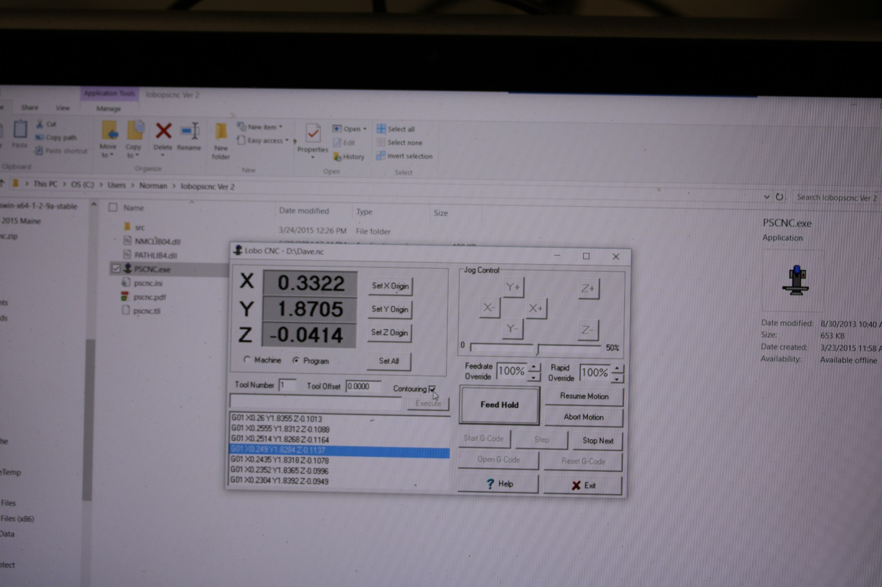

Figure - PSCNC Software running a G-code file.

In the photo above a G-code program is running, but when the machine is stopped you can use the Jog Control to move LoboCNC’s 3 axis. The current position is shown in the X, Y, and Z windows. **Movement is relative to the bit**, so –X movement moves the table to the right, and +Y moves the table forward.

## The Router

The LoboCNC uses a Makita laminate/trim router, although it can take other 2” diameter routers. The Makita comes with a split collet chuck for ¼” bits. Split collets are good in that they tend to center the bit well, but don’t get as good a grip on the bit as Weldon collets. The NovaLabs LoboCNC mill has a “Weldon” style collet that holds 1/8” and possibly other bits. In my own shop I’ve made 1/8” and 3/8 “split collets which work well, and I can make some for NovaLabs as well.

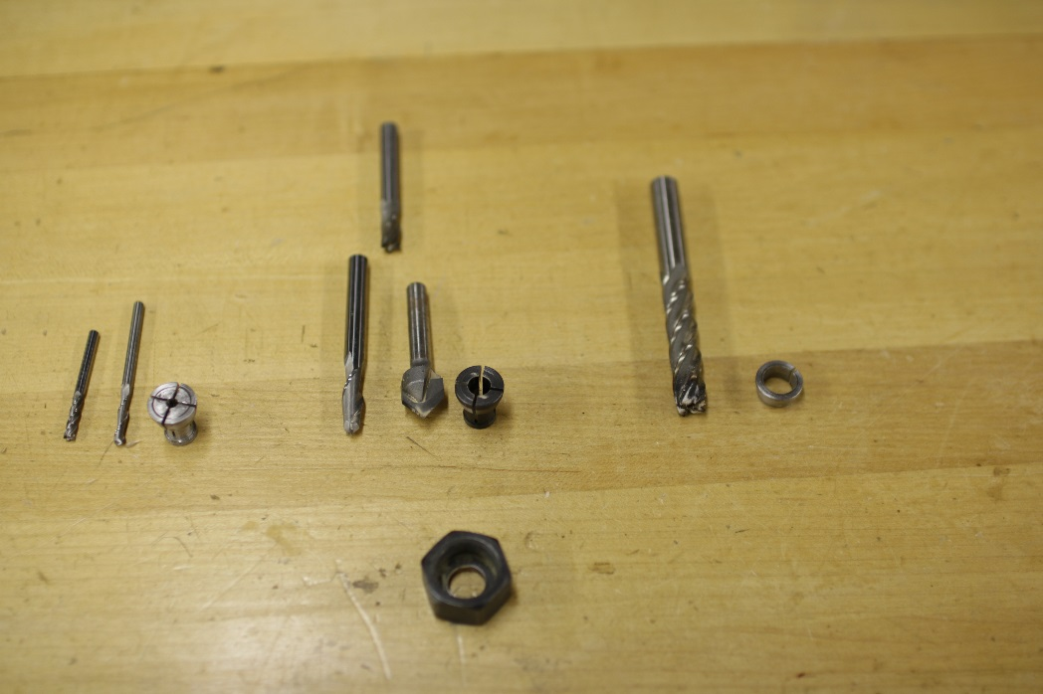

Figure – 1/8”, ¼” and 3/8” split collets with cutters and collet nut

You typically use either router bits or end mills in the router. There are a wide variety of bits available but the commonly used ones are straight, ball end, and V bits. End mills typically come in 2 and 4 flute designs. 2-flute bits are often center cutting, so they can be plunged, 4-flute bits sometimes don’t cut in the center and don’t work well for plunging. You can see how the 4-flute below left would have a problem center cutting.

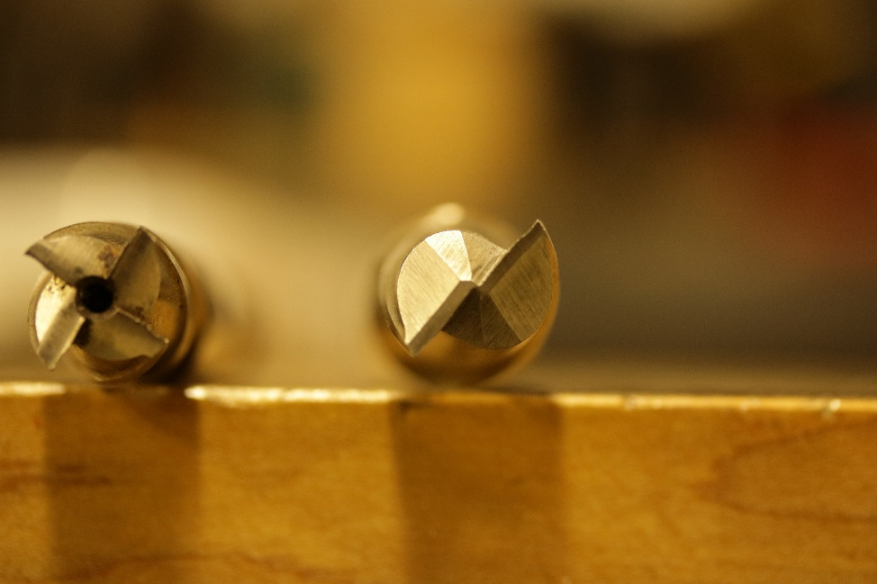

Figure - non center cutting 4-flute(left) and center cutting 2-flute end mill (right)

## Materials

I’ve used my Lobo to cut hardwood, phenolic plastic, nylon, and MDF. I haven’t tried metal but Jeff Kerr says it works fine for shallow cuts in soft metal as well. Wood cuts great but you need some sort of vacuum cleaner to clear the chips.

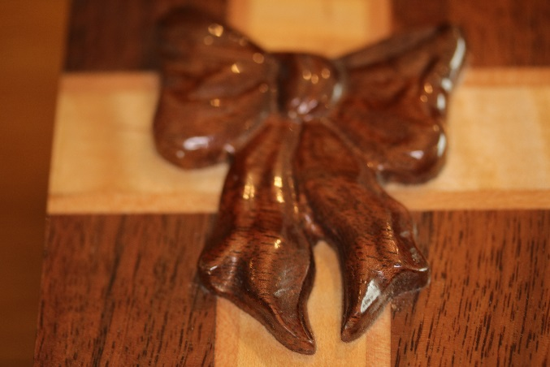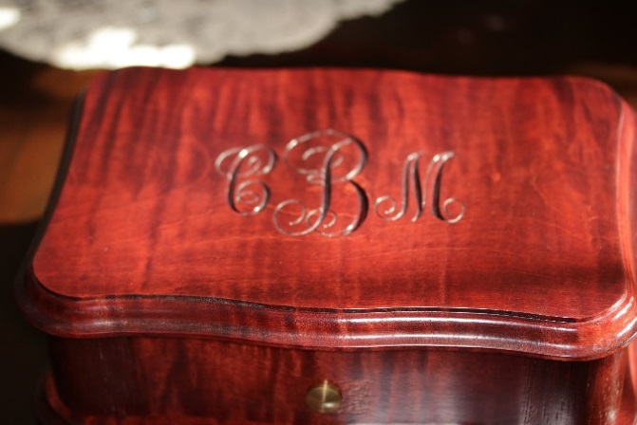

Phenolic plastic (garolite) machines well and doesn’t soften with heat so it is good for 3D printer parts that get hot. You can get sheets of it at McMaster-Carr.

Photo of Garolite.

You can also machine thermoplastics, but have to be extra careful to remove chips. Acrylic and Lexan machine well, but the chips will melt and clog up your cutter. If you are not very careful you end up cutting with a ball of melted plastic, which doesn’t work well. I often use a flow of compressed air to blow chips away from the cutter when cutting thermo-plastic.

Photo of phone case

## Holding the workpiece

Lobo has a plywood spoil board with holes in it to

# Three projects

I’ll demonstrate three different projects on the LoboCNC. The first project will be a simple part showing profiling and pocketing operations. The second one shows V-carving of lettering into a board. The final project shows carving a 3D bow into a piece of wood.

## Lobo_part1 – A simple 2.5D project

The part is 3-1/4” by 2-1/4 cut from ½” material. The inner circle is routed .25 inches deep. The area between the outer circle and square is routed 3/8” deep. The outside of the part is cut all the way through. The simulation below shows what the part will look like.

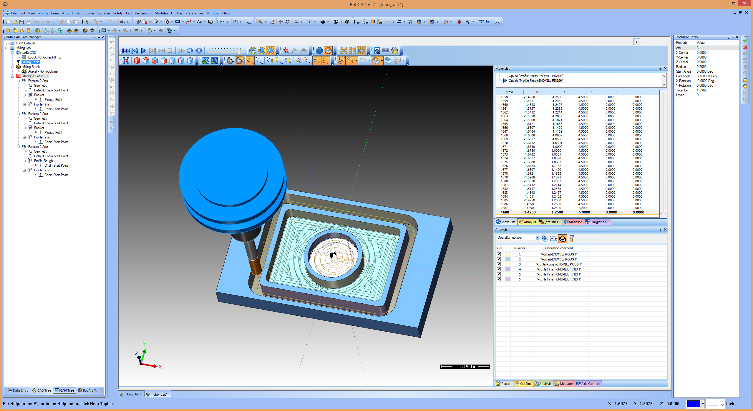

Figure - Lobo_Part1 Simulation

### Drawing the 2D Part

You can use any CAD tool you want to draw the part, as long as it exports DXF files. I used BobCad/CAM in this example for drawing this part, but you could also draw it directly using CAMBAM. CAMBAM is a relatively low cost ($150) CAD/CAM tool which does a lot for its price. You can use CAMBAM free for up to 40 uses.

The drawing below is the 2D line drawing I made using BobCAD. Whatever CAD tool you use, **you have to import the drawing into CamBam** to create the G-code using [CamBam’s](http://www.cambam.info/) CAM features.



Figure – Lobo_Part1 2D drawing in BobCad

### Import DXF file into CamBam

Once you open the DXF in CamBam, you will see various drawing objects organized into layers. What you see depends on your drawing program. In this case you see some polylines which represent different drawing elements. Clicking on an element highlights it in the drawing as well as the list.

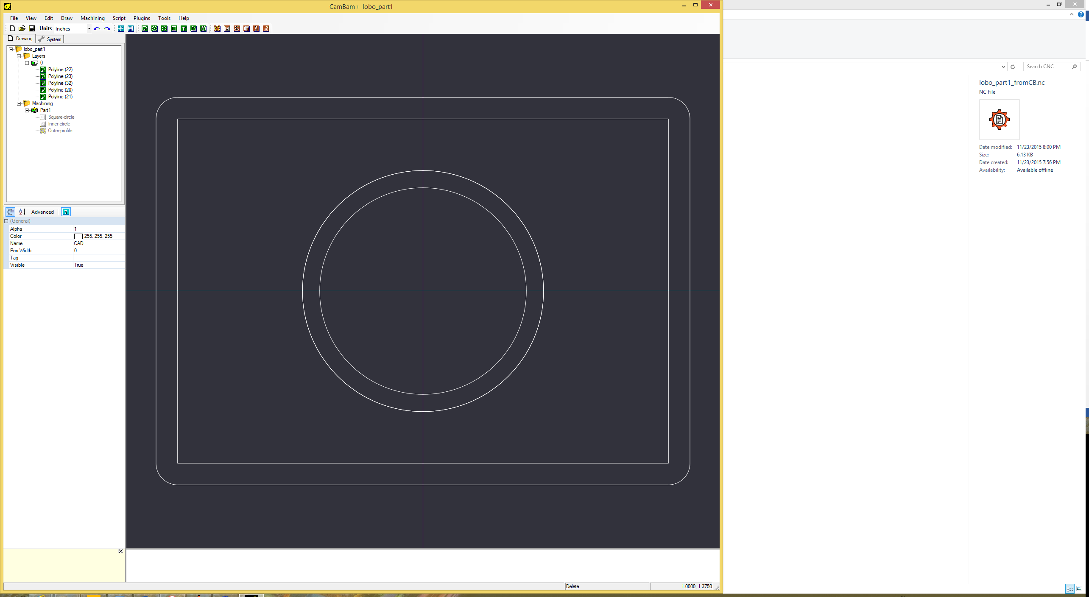

Figure - DXF file imported into CamBam

### Defining Machining Operations to make a 2.5D object

The basic idea in CamBam is to pick drawing elements and define the machining operations that are required to make the elements. CamBam supports profile, pocket, drill, and engrave operations.

### Coordinate Center

The first thing you should do is define the coordinate center for the part.

Screen shot for specifying center.

In this example, I’ll start with the area inside the inner circle. I select the circle and then a pocket operation. I fill in the parameters for depth (-0.25”), travel speed of 10 inches/minute, depth increment of 1/8 inch, and tool diameter (0.25”).

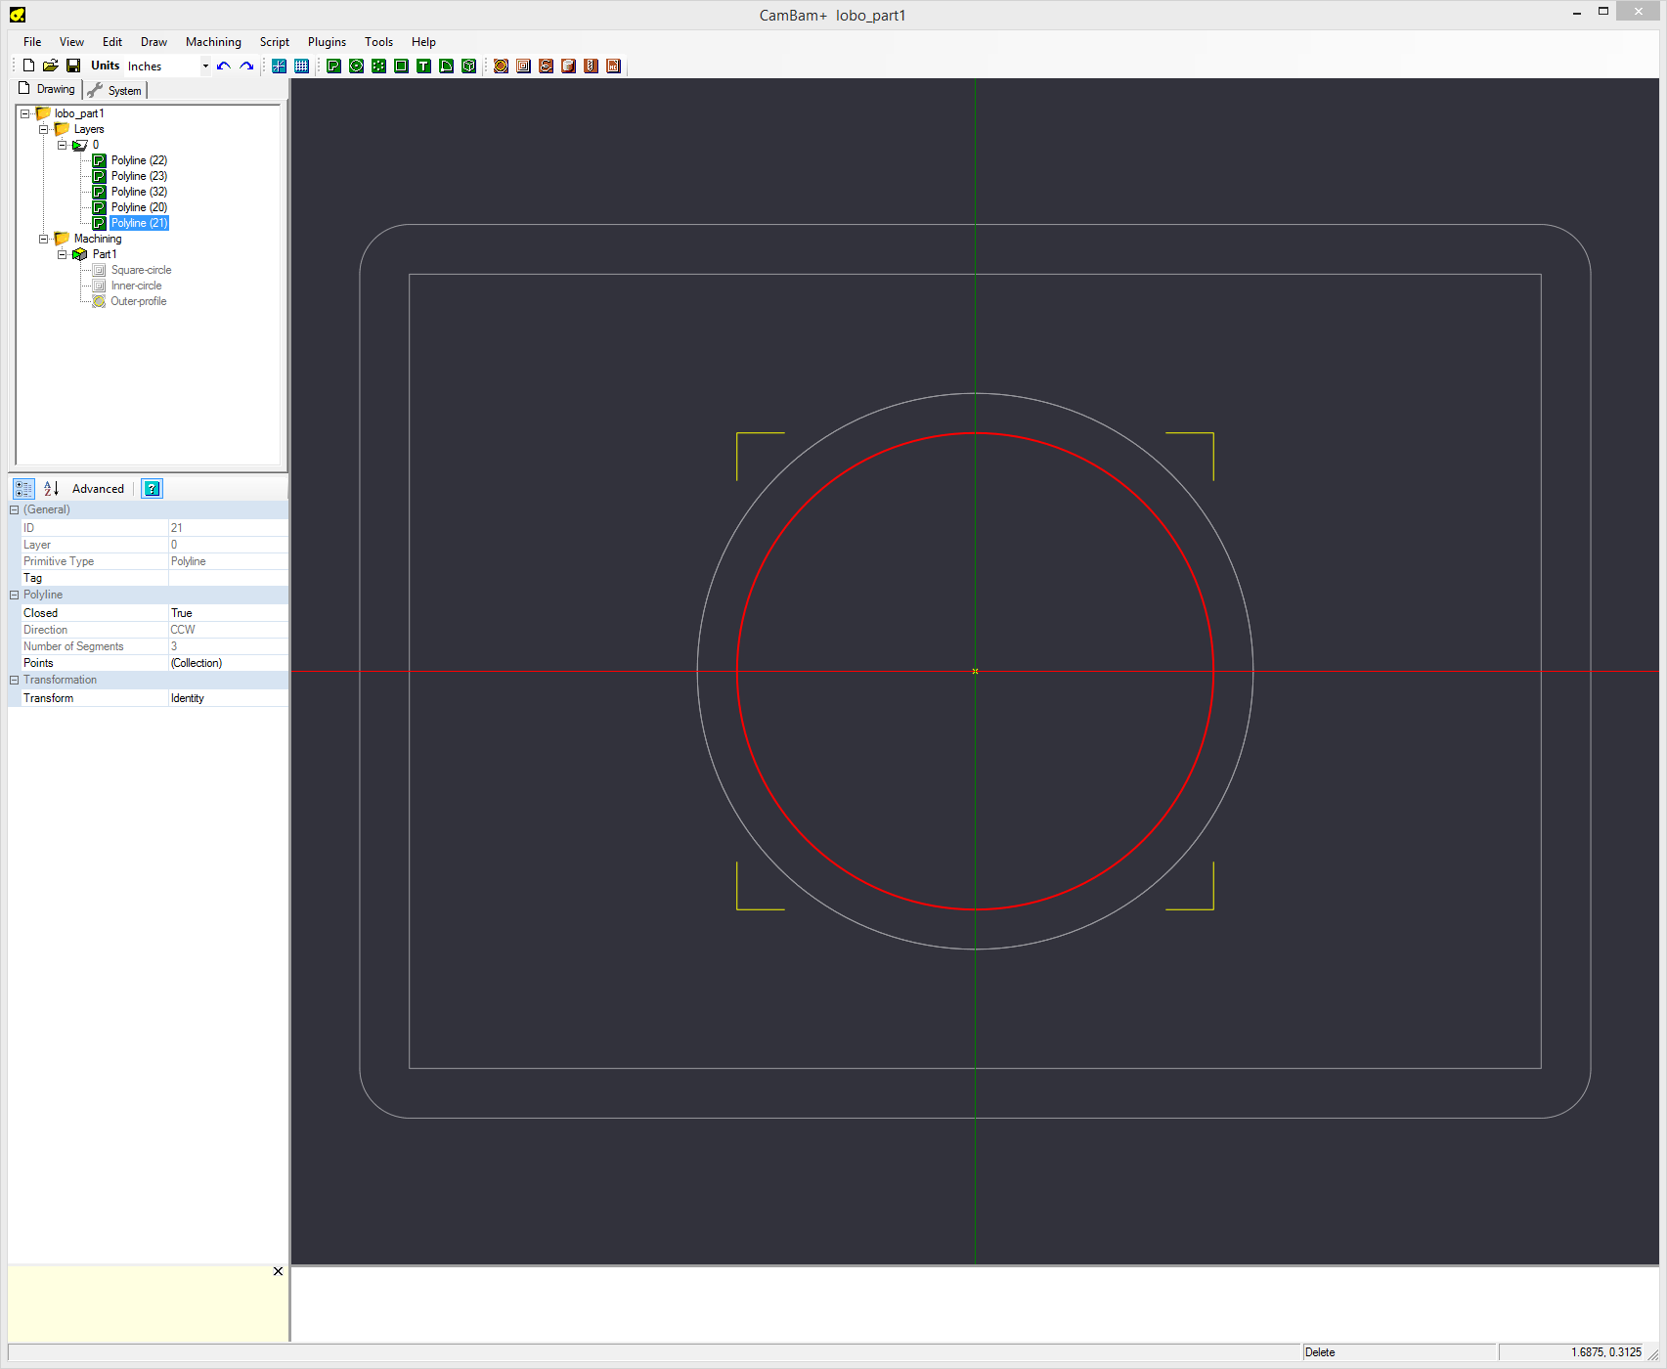

Figure - Specifying machining information for Inner Circle

Next, I’ll add a **pocket** operation for the area between the red square and the outer circle. I select both the square and outer circle, and then pick the pocket operation from the buttons at the top of the screen on the right. That adds a machining (MOP) entry under Part1, which I’ve renamed Square-circle. I then filled in data about the tool type (0.25” dia, depth of cut (-0.375). and travel speed (10”/min) .

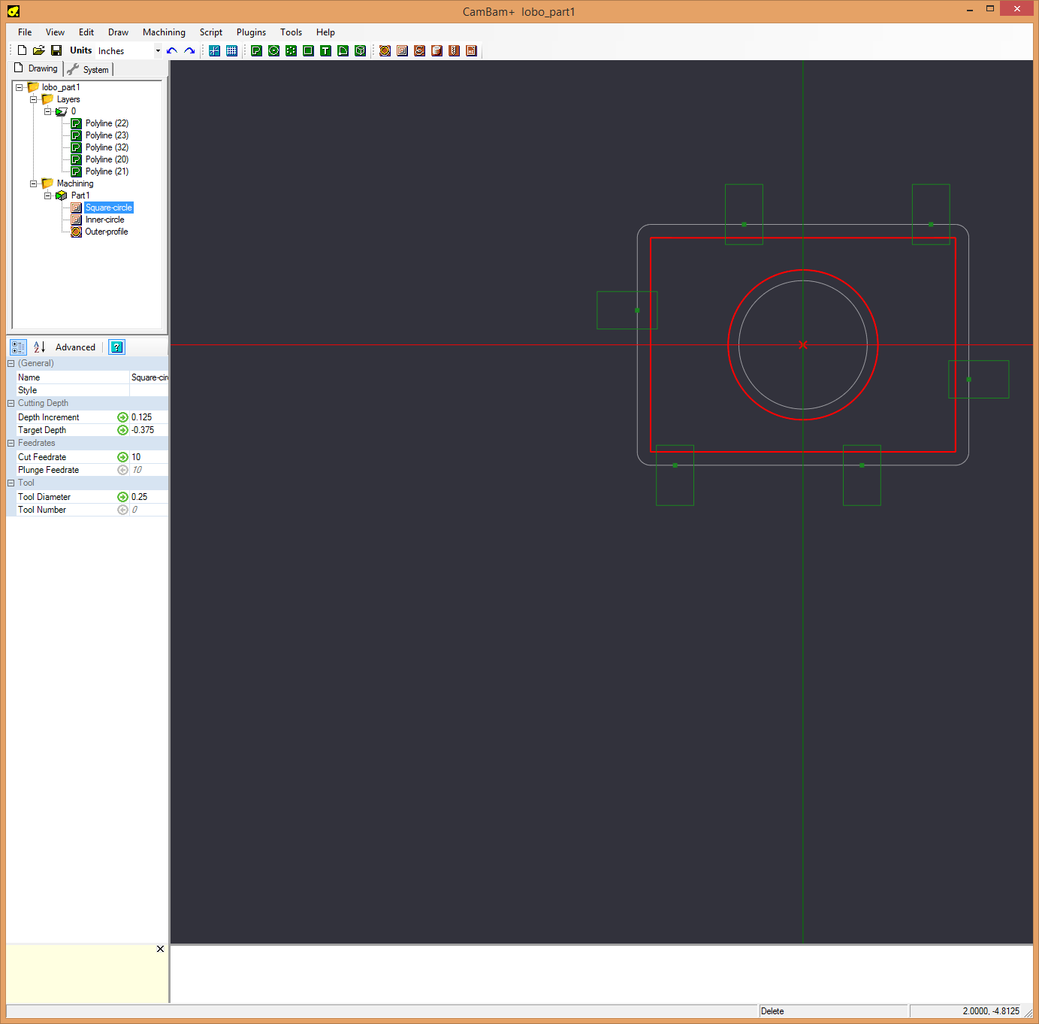

Finally, I’ll add a **profile** machining operation for the perimeter of the part. In the machining details I picked a tool diameter of 0.25, a depth of -0.500, depth increment of 1/8 inch and forgot to update the travel speed, so I’ll have to go back and set it to 10 later.

### Adding Holding Tabs

**Note that I also selected tabs for the profile**, which will hold the part in place when machining is done and will have to be cut off later. LoboCNC doesn’t work like the laser cutter and **you must not leave parts free floating** while machining. You select the number, width, and height of the tabs and CamBam puts them in for you. You’ll see the tabs later in the back plot. You should be sure to place the tabs in locations that will be easy to clean up after you cut the part free. In this case, the tabs are on straight sections that will be easy to sand.

If you look closely, you will see that I used the same tool for all operations, so there should be no tool change after you install the first tool. **If you use multiple tools, you have to rezero the Z origin after a tool change**. Leave the X and Y alone or you’ll ruin your part. Normally you change the tool, and manually lower the carriage to the zero reference (normally the top of the workpiece). Then set the Z origin.

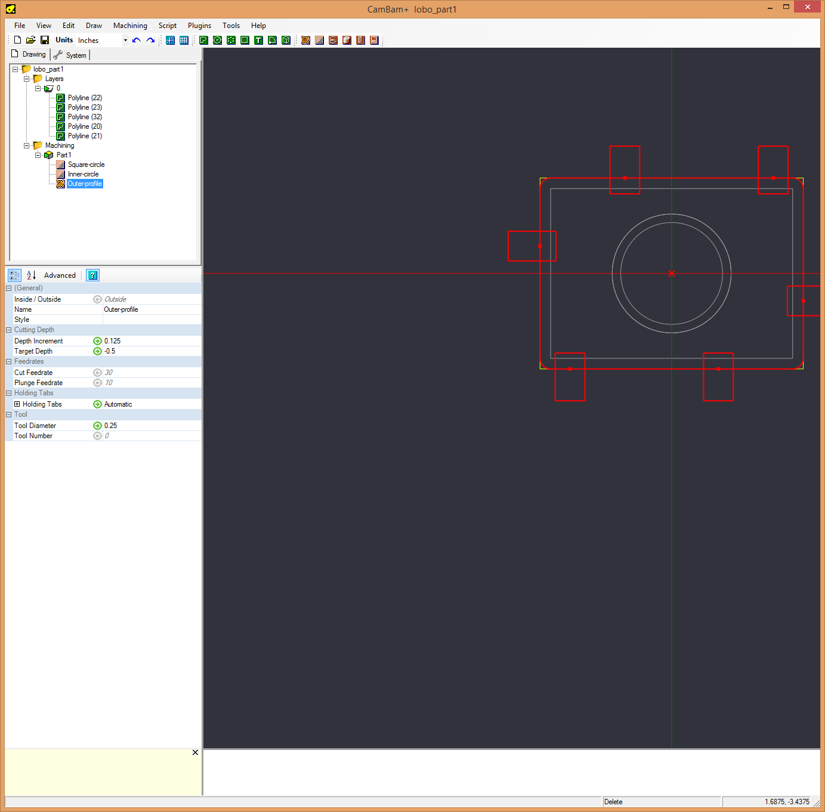

Figure - Specifying parameters for profile operation

At this point you can tell CamBam to generate the toolpath by right-clicking on the Machining tab in the part tree. The figure below shows the tool paths.



Figure - CamBam tool paths

### Generating G-code and running the back-plotter

Now, we’re ready to generate some G-code. Right click on the machining tab and select “generate G-code” to produce a G-code *.nc file. I have the *Predator* G-code simulator that came with BobCad/Cam, that can simulate what the G-code will do on the LoboCNC. The figure below shows what our part should look like. 

Figure - G-code plotted by back plotter. Note the tabs.

### Running the Machine

If everything looks OK in the back-plot the next step is to make the part.

1. Securely Install the workpiece on the mill. You can use clamps or screws through a part of the workpiece that will not be machined. I use ¼” nylon screws on my LoboCNC to hold parts to the table, but place some scrap under the workpiece to avoid cutting into the table.
2. Launch PSCNC.exe. It will prompt you to turn on the S3X3 controller power (switch on right) and ask if you want to home the axis, which you should do. PSCNC will move the Z axis to the top, and the X and Y axis to their zero position (left front of table). It does this by driving the servo motors until they stop turning. **Make sure there is nothing on the table when you do this.**
3. Move the G-code *.nc file to the machine where PSCNC.exe is running using a usb drive or network.
4. Open the G-code file in PSCNC. You should see the G-code for your part and the heading should tell you something about the part
5. Move the router bit to the coordinate center you picked when you produced the G-code and zero all PSCNC axis settings.
6. Move the z-axis up several inches above the workpiece to a safe position, and re-zero the z-axis.
7. With the router off, run the G-code to see if it looks reasonable. You can speed up the speed if you want once you verify the movement speed looks about right. **Be ready to abort the operation if things go wrong.**
8. If you can “air cut” the part, you are ready to make a test cut. I recommend testing on a piece of scrap the first time you try a design to avoid ruining your workpiece due to some unforeseen issue.
9. Put in the first router bit your project will use and **securely tighten it** in the router
10. Reset the G-code and move the z-axis so the cutter is at the coordinate center you picked. Re-zero the z-axis position.
11. Move the z-axis up to a position where it will clear the workpiece. Don’t re-zero the z-axis at this point, you just want some clearance in case the G-code makes the bit zoom across the workpiece.
12. Start the G-code and you should be prompted to insert the first router bit and then to turn on the spindle.
13. Cross your fingers and be ready to abort in case of error.

The figure below shows the part as machined. I put a piece of paper under it to highlight the holding tabs which are still in place.

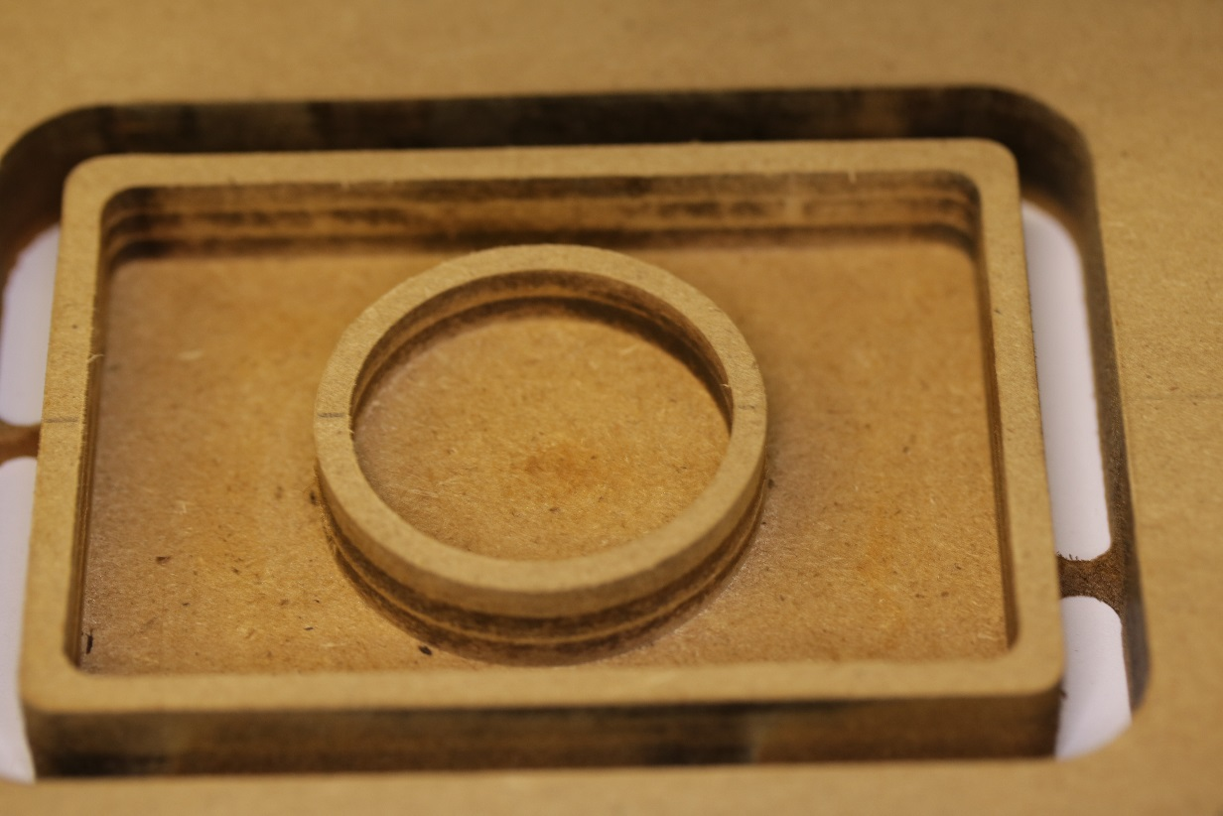

Figure 16 - Final part machined from MDF. Notice Holding Tabs

## Lobo_part2– V-Carved letters

V-Carving is a process for engraving lettering and patterns using a V shaped cutter and varying the depth of cut to fill in the space between the font outline or between lines in the pattern. It is often used for signs and lettering.

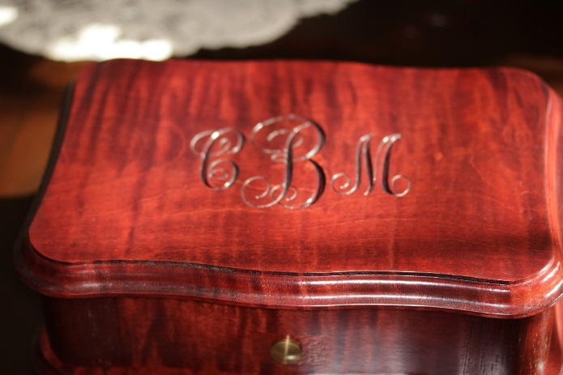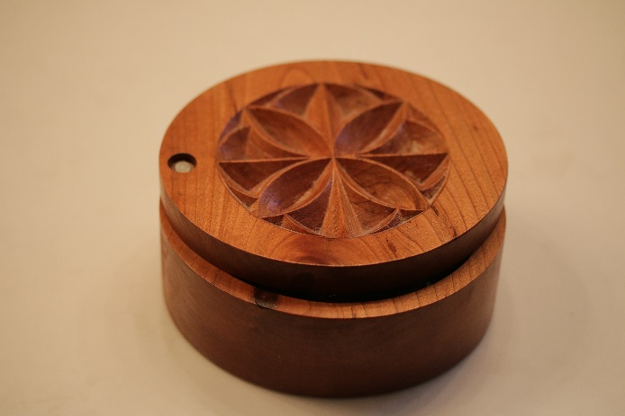

Figure 17 - V-carved monogram on music box and pattern in saltbox

F-Engrave is a free program for generating G-code for V-carving.

## Lobo_part3– 3D project

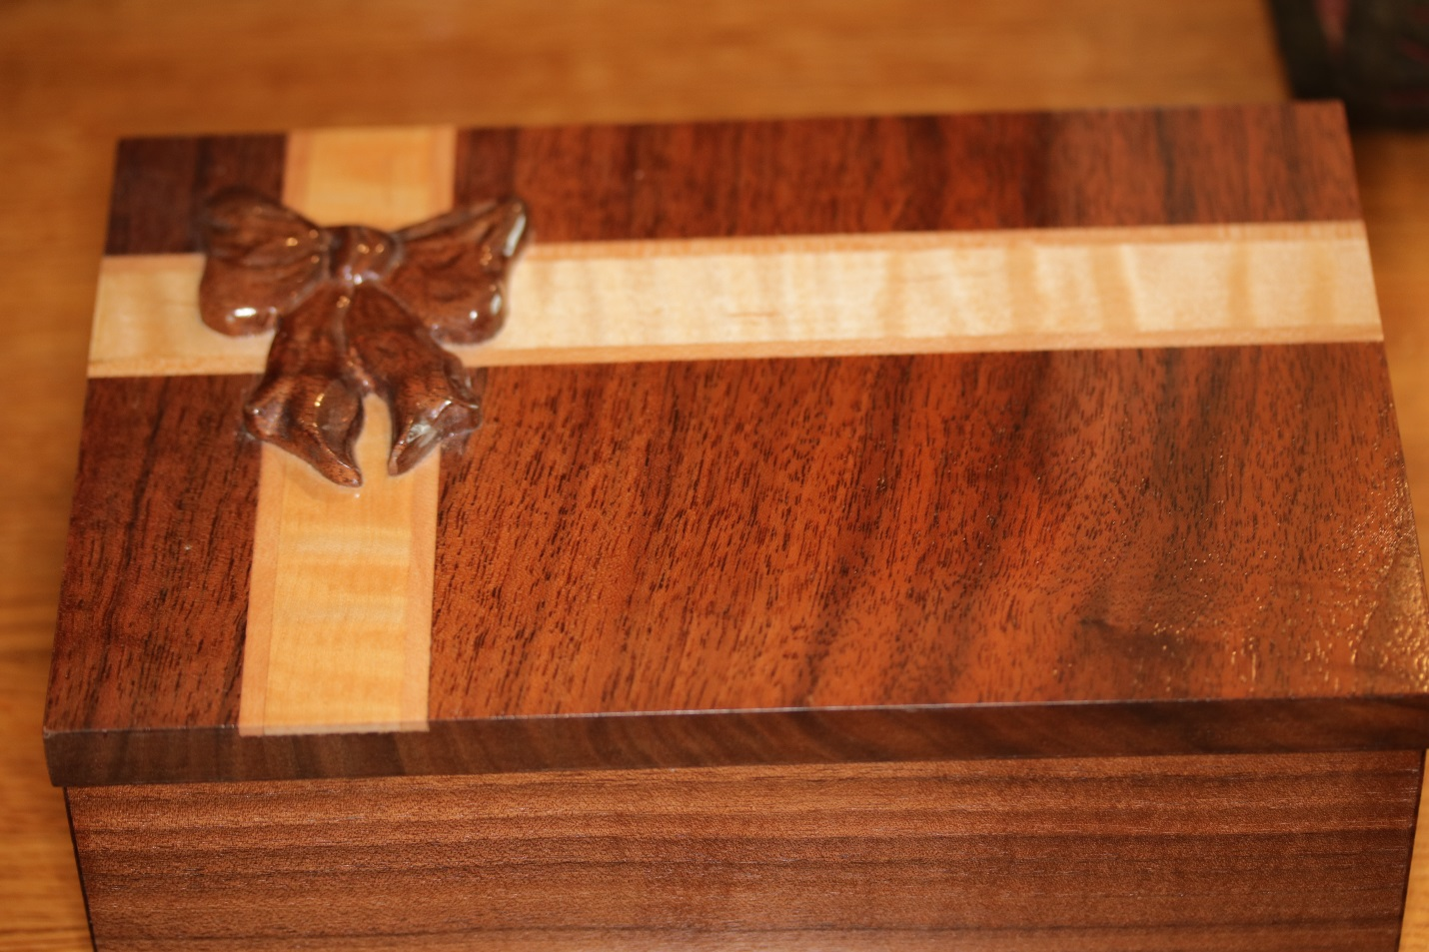

Figure 18 - 3D carved bow on small box

## Tips

1. Keeps speeds and depth of cut low to avoid breaking tools. A router can only cut so fast. You may only specify 50% step over, but the first cut will be full width. LoboCNC can move at a max rate of about 30 inches/minute, but that is way too fast for most operations.
2. Use the largest diameter bit you can for your part. Small diameter bits will flex under the forces of routing, expecially if you move too fast. For pocketing you can make multiple roughing passes using a larger bit like 3/8”, and then a finishing pass using a smaller bit to get tighter corners.
3. Register the workpiece on the bed in a known orientation so you get it back to this position if you have to remove it for some reason
4. Put a reference point somewhere on your part at a known location. It can be outside of the part, or at a place that won’t show. One method that works is to have the bit cut a 1/16 inch deep hole somewhere off the part. That way if you have to recut the part you can manually put the bit in the hole and set the exact X and Y positions.
5. You often need to re-zero the Z-axis on each part to make sure the height is right if the thickness varies. This is especially important if you are engraving small letters. I often have to re-zero the Z-axis a few thousands lower and recut a piece if the letters aren’t as deep as I would like.

## Hybrid techniques